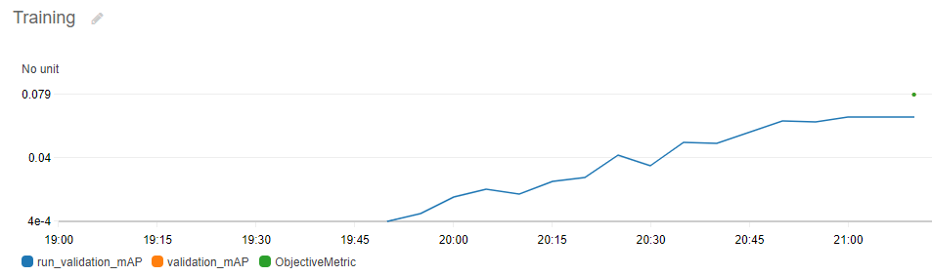

**Key Value**

batch_size: 36

epochs: 85

lr: 0.0007867490924223497

lr_factor: 0.47553303406278213

model: "yolo3_darknet53_custom"

wd: 0.00015810790604070483

Optimizer: Nadam

MAP: 0.0794951319694519